**Ruparel Zion in Sion –**

**About Project:-**

A renowned name in the Mumbai real estate market, Ruparel Realty is launching new upcoming luxurious development project in Sion Mumbai, ‘Ruparel Zion’. This is one of the beautiful and luxurious projects in Mumbai with perfect blend of greenery and modern development with world class amenities. This is the family-friendly project which is designed with 21 storey towers of 2 bhk apartments with extremely beautiful residence managing all exclusive health and recreation amenities on Rooftop and many more.

**Project Configuration Details:-**

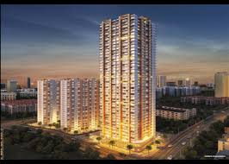

The luxurious residential apartment of Ruparel realty, Ruparel Zion is an iconic and eye-catching project developed in the prime location of the Mumbai. The project comprises premium 2BHK residential apartment with configuration starting from 692 sq-ft. These project is constructed in a deliberated location at sion circle were offers seamless connectivity to the Eastern Express Highway, Sion Railway station, Western Express highway and Sion-Bandar link road are few minutes away from the project location. It is also not far away from the business hub Bandra Kurla complex which famous for the Industrial estate.

**Highlights:**

* Premium 2BHK luxurious 21 story’s apartment towers.
* Well-equipped room facilities with basic requirements and amenities.
* Transportation connectivity to all major cities.
* Family-friendly community easy accessible to health centers, schools, malls.

**Project Amenities:-**

Each room of the Ruparel Zion is designed with modern architect featured with all equipments such as living rooms are generous in space with imported flooring, High-tech Automation system, elegant bedrooms, modern kitchen, luxury bath spaces with world-class sanitary ware, video door phone security. The property tower also has a exclusive amenities like air-conditioner grand lobby, CCTV Surveillance and security system, High-speed lift with designer lift lobbies, advanced integrated fire safety and 24/7 power backup for common areas. Other than these, there is a rooftop exclusive healthy and recreation amenities including sky party lawn with pergolas and sit-outs, sky swimming pool with lounges, poolside deck with juice bar, senior citizen’s zone with sit-outs, exclusive acupressure pathways, skywalk with green plantations and sky observation with telescope.

**Transportation facilities:-**

The Project was constructed in a prime location of the Mumbai, Sion Circle in Mumbai. This is the central area in Mumbai where all the major routes can be easy connected to it. The area is easy connected to all the major cities by using various transport modes like railways, airlines, metro line, bus, taxes, private vehicles etc. The most nearest metro station is Ghatkoper station where you can also access for the airlines through the metroline. The city also connects to all the three routes of railway lines include central, western and harbon lines. Other than this all the various facilities like bus, tax are also available to make your travel easier.

**Neighborhoods facilities:-**

This luxurious residential community project also has the advantage to make the location easy access to all the renowned facilities like educational institutes, business hubs, healthcare centers, hospitals, shopping malls, grocery shops, gymnasium, etc. Parents don’t want take worry about their Childs education, there are numerous school are available in the locality such as Edubridge International schools, Queen Mary School, Christ Church School and JBCN International Schoolmate. For the health care facilities, there are Tata Memoral Hospital, KEM Government Hospital’ and Nowrosjee Wadia Hospital and many more are quickly accesses able from the community location. The Shopping malls for daily grocery needs there are High Street and Podium mall, Atria Mall and mega Mart.

**About Developer:-**

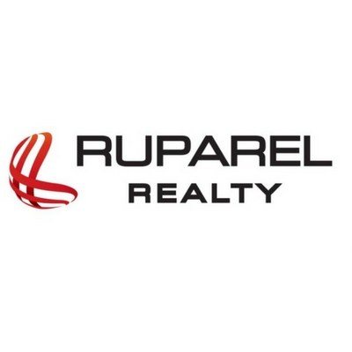Ruparel Realty is one of the most famous developers in Mumbai, which was established in year 2000, constructed numerous residential and commercial projects and made a unique identity in the real estate property development. The ongoing project of the company is on his major project in the metropolitan region, constructing 2 million sq.ft lands.

The company also been working with the top real estate companies include JW Consultants, Aakar architects and consultants, Eskayem Consultants, ACC and Skyway RMC. Working with top real estate, using latest technologies, company cannot compromises in the quality standards and ensure to delivery in timely. There are many projects are developed namely Ruparel Ariana, Ruparel Iris, Ruparel Orion and Sea Palace and many more. Rather than these, Company has purchased a land ranges from 5-20 acre in major cities like Kandivali, Parel, Western and central suburbs area. This makes the company to move towards the success.

The luxurious properties and growth of success comes from the strenuous efforts of employees, there is no boundaries in hiring the best employee for the job. There are more than 100 best talented employees are hired in past 12months.The real motive of the company to develop work culture with intent of moving towards success with high-end standard equipments. The enormous success is marked by the finance institutions like L&T Finances, SBI bank, and Axis Bank, ICICI Bank.